Physics: 9. Force, Work and Power
Please remember to photocopy 4 pages onto one sheet by going A3→A4 and using back to back on the photocopier

Questions to make you think
      - Is there gravity on the moon?
      - Why is there an atmosphere on Earth but not on the moon?
      - How does your weight vary as you travel from earth to the moon?

Syllabus
OP4 Appreciate the concept of force, recall that the newton is the unit of force, and describe forces and their effects

OP5 Investigate examples of friction and the effect of lubrication

OP6 Investigate the relationship between the extension of a spring and the applied force

OP7 Recall that weight is the force of gravity and that weight can vary with location; recall that mass in kilograms multiplied by 10 is approximately equal in magnitude to weight in newtons on the surface of the earth.

OP15 Define and give the units for work, energy and power, state the relationship between work and power, and perform simple calculations based on this relationship

Student Notes
Force
A force is something that can cause an object to change velocity or accelerate

The newton (symbol N) is the unit of force.

Forces can be measured using a spring-balance (the proper name is a newton-meter).

Friction
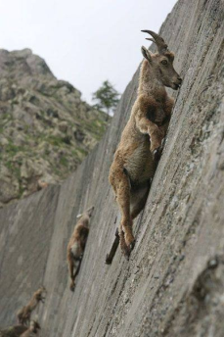
Friction is a force that opposes motion between two objects in contact.

Friction can be a nuisance (e.g. it slows things down when you don’t want it to when driving a car or riding a bike).
Friction can also be useful (e.g. brakes on a bike, and to enable us to walk).

Experiment:
To demonstrate friction and how a lubricant can be used to reduced friction.
Attach a spring balance to a wooden block and use it to pull the block over the bench. Note the reading on the spring-balance.
Now put some oil or grease under the block and repeat.
Notice that the force required to pull the block is much less.
Hooke’s Law
The extension of a stretched string is directly proportional to the force that is stretching it

This means that if the force on the string doubles so will the extension; if the force triples then the extension will also triple, etc.

Experiment: To investigate the relationship between the extension of a spring and the force that is stretching it.
- Use a newton-meter to stretch a spring and note the extension and the force used.
- Repeat for lot of different forces.
- Plot a graph of force used against extension.
- Result: Your graph should be a straight line.
- Conclusion: The graph is a straight line through the origin which shows that the extension is directly proportional to the applied force.

This is what your graph should look like:

{Strictly speaking stating Hooke’s Law is not on the syllabus but it did get asked by mistake one year so it’s best to learn it just in case it happens again. You do however have to know the experiment.}

Why doesn’t my line go through the origin?

Mass is a measure of the amount of matter (“stuff”) in something.

The weight of an object is a measure of the gravitational pull on it.
Weight is a force (due to gravity)

The mass of an object doesn’t change from one place to the next because it still has the name amount of stuff inside (the same number of atoms), but the weight of the object will be much less on a planet smaller than Earth (or on the moon) while it will weigh much more (it will be much ‘heavier’) on a bigger planet. In fact if you could go to one of the bigger planets you would not even be able to stand up because you weigh so much!

Maths Problems
Weight (in newtons) = Mass (in kilograms) × 10

e.g. a student of mass 60 kg has a weight of 600 N.

Note: There are 1000 grams in a kilogram (kg).

A little more on Mass and Weight
There is a very important and often misunderstood difference between mass and weight.
Mass is the amount of matter present in the object. It doesn’t change, i.e. the amount of ‘stuff’ in your phone doesn’t change, regardless of where you bring it (even if you bring it to the moon it will still have the same number of atoms in it.)

Another way to look at it is to compare weight, which is caused by gravity, to magnetism.
Bringing a magnet from one place to another won’t change the amount of stuff (mass) in it, but if you bring the south end of a magnet closer to the north pole of another magnet it will experience a greater attraction to the north pole. It will appear to be heavier. The force of attraction between two magnets depends partly on the strength of the two magnets. Similarly the force of gravitational attraction between two objects depends partly on the mass of the two objects. ‘Weight’ is our shorthand way of talking about gravitational attraction.
So the gravitational attraction between you and the Earth is greater than the force of attraction between you and the moon.

Weight is the force with which the object is attracted to the Earth (or other planet) by gravity.

Weight (in newtons) = Mass (in kilograms) × 10
The number 10 is an indication of the size of the force of gravity. It would be too much of a coincidence for it to be exactly 10. It turns out to be about 9.8, and because the force of gravity is less on the moon than on the Earth, this number is smaller for the moon (it’s about 1.6).
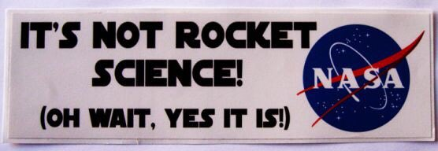

Energy, Work and Power
Energy
Energy is the ability to do work

The unit of energy is also the joule.

Work
Work done = Force × distance

The unit of work is the joule (J).

Power
Power is the rate at which work is done

$$Power=\frac{Work}{Time}$$

The unit of power is the watt (W)

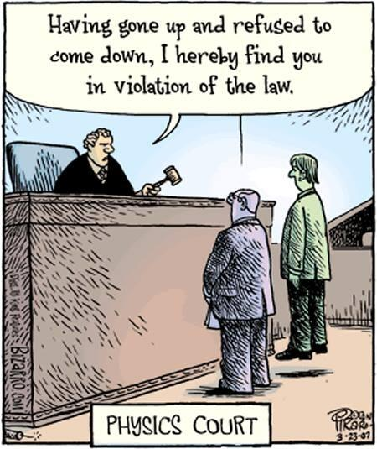
Exam questions
- [2007 OL]
Metre
Newton
Joule
Different units are used to measure different physical quantities.
  - Pick the unit of length from the table on the right.
  - Pick the unit of weight from the table on the right.

- [2011]
- Explain the term friction.
- How can friction be reduced?

- [2009 OL]
Friction can be useful when driving a car.
- Name one way in which friction is useful when driving a car.
- Name one possible way to reduce friction.

- [2006 OL]
Friction is an example of a force.
  - Give another example of a force.
  - Give one way to reduce friction.
  - After what scientist is the unit of force named?

- [2008][2012]
Give two effects that gravity has on your everyday life.

- [2009]
- A stone was dropped from the top of a tall cliff. Name the force that causes the stone to fall downwards.
- The stone had a mass of 2 kg. What was the weight of the stone on earth? Give the unit.

- [2006] Distinguish between weight and mass.

- [2006]
State Hooke’s law.
{This isn’t on the syllabus and shouldn’t have got asked, so presumably won’t appear again – but you never know}

- [2009 OL]
A student investigated the relationship between the extension of a spring and the force applied to it.
The equipment shown in the diagram was used.
The data collected is shown in the table.
Force (N) | 0 | 2 | 4 | 6 | 8
Extension (cm) | 0 | 4 | 8 | 12 | 16

The student then drew the graph shown.
Answer the questions that follow about this investigation.
- Name an instrument used to measure the force in this investigation.
- Describe how the student could have measured the extension of the spring.
- What conclusion would you draw from this investigation?
- [2006 OL][2012 OL]
A student carried out an investigation to examine the relationship between the extension (increase in length) of a spring and the force applied to it.
The diagram shows the apparatus used.
The table shows the data collected by the student.
Force (N) | 0 | 2 | 4 | 6 | 8
Extension (cm) | 0 | 4 | 8 | 12 | 16

  - Describe how the student could have taken any one of these measurements.

  - Draw a graph of the extension (y-axis) against the force in the grid provided on the right.

  - What force results in a 6 cm extension of the spring?

- [2006]
A student was given a box of identical springs and asked to analyse them so that they could be used as newton meters. The student performed an experiment, using the apparatus shown in the diagram, on one of the springs.
In the experiment the student measured the increase in length of the spring caused by a number of weights. The spring was tested to destruction (that is weights were added until the spring was damaged).
The data from the experiment is given in the table.
Weight (N) | 0.0 | 0.4 | 0.8 | 1.2 | 1.6 | 2.0 | 2.4
Extension (cm) | 0.0 | 2.0 | 4.0 | 6.0 | 8.0 | 8.5 | 8.6

- Plot a graph of extension (increase in length – y-axis) against weight (x-axis) in the grid provided.

- Use the graph to find the weight that would produce an extension of 5 cm in the spring.
- Study your graph carefully.
The spring obeys Hooke’s law for the earlier extensions and then when the spring becomes damaged it does not appear to do so.
Estimate, from your graph, the weight after the addition of which the law seems no longer to apply.

- [2010]
A pupil used the apparatus shown in the diagram to investigate the relationship between the force applied and the extension produced in the spring by that force.
Pointer, P, was used to read the scale.
Weights were added to the pan to apply forces to the spring.
The data recorded is in the table.

Force  (N) | Scale reading  (cm) | Total extension  (cm)
0 | 31.0
2 | 35.0
4 | 39.0
6 | 43.0
8 | 47.0
10 | 51.0

- Calculate the total extension for each force and enter them in the table.
- Draw a graph of force against total extension in the grid below.
- What conclusion can be drawn from the graph regarding the relationship between the force applied to the spring and the extension produced by it?
- Use the graph to determine the weight of a stone that produced an extension of 14 cm in the spring.

- [2007]
The driver of a moving car applied the brakes.
The brakes produced an average stopping force of 8 kN (8000 N), and the car stopped having travelled 20 m after the brakes were applied.
Calculate the work done in stopping the car.

- [2006]
A girl of mass 60 kg (weight 600 N) climbed a 6 m high stairs in 15 seconds.
Calculate the work she did and the average power she developed while climbing the stairs.

- [2012]
Define the Watt, the unit of power.

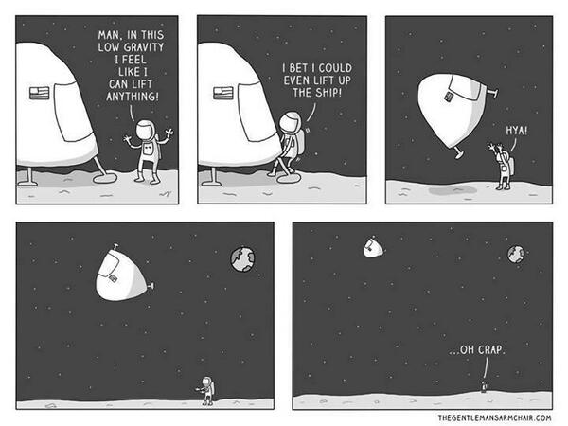
Exam Solutions

- Metre
- Newton

- Resistance to movement of one surface over another/ force that opposes motion
- Smooth surfaces/ lubricant/ named lubricant/ choice of materials…

- Grip / traction / road holding / stopping
- Oiling / waxing / greasing / polishing / lubricants / bearings

- Gravity / weight / push / pull / magnetic / electric / twist
- Oiling / lubrication / wax / polish / ball bearings
- Newton
- It gives things weight/ it keeps things on the surface of the earth/ it causes things to fall…

- Gravity
- Weight = mass × 10 = 2 × 10 = 20 N (Newtons)
- Weight is a force which is caused by gravitational pull.
Mass is a measure of the amount of matter in something.
- The extension of a stretched string depends on the force applied to it.
- Add (hang) weights onto the string and measure the extension using the metre stick
- Plot all the points and draw a straight line.
- 3 N

- Spring balance / Newton meter
- By using a ruler or a metre stick
- The extension is directly proportional to force applied / as force is increased the extension increases at the same rate.

- See graph
- Weight = 1.0 N (accept range 0.9 to 1.1)
- 1.6 N (accept range 1.6 to 2.0)
Force  (N) | Scale reading  (cm) | Total extension  (cm)
0 | 31.0 | 0
2 | 35.0 | 4
4 | 39.0 | 8
6 | 43.0 | 12
8 | 47.0 | 16
10 | 51.0 | 20
- See table
- See graph
- The extension is directly proportional to applied force (you must use the word directly)
- 7 N

- Work (= force × distance) = 8000 × 20 = 160000 J

- Work (= force × distance) = 600 × 6 = 3600 J.
Power (= work/time) = 3600/15 = 240 W.

- The watt corresponds to one Joule per second
General Questions

- Give an example of how friction can be useful on a bicycle?

- Give an example of how friction can be a nuisance on a bicycle?

- How might a cyclist reduce friction?

- Give another example of how friction can be useful.

- Give another example of how friction can be a nuisance.

- Describe how you would investigate the effectiveness of two different lubricants.
Include reference to a control.
Give three ways of making sure that you carry out a fair test.

- Name two instruments used to measure weight.

- Calculate the weight (in Newtons) of a bag of sugar, which has a mass of 5 kg.

- A man has a mass of 100 kg. What is his weight?

- Would the man weigh less or more on the moon?

- Why does the man have a different weight on the moon?

- What will be the mass of the man on the moon?

- How would you be affected if your weight suddenly doubled?

Energy, Work and Power
- Define the term ‘work’.

- What are the units of work?

- Define the term ‘energy’.

- What are the units of energy?

- Define the term ‘power’.

- What are the units of power?

- A force of 20 N was used to pull a sofa 3 metres across a room. How much work was done?

- If the time taken in the previous question was 10 seconds, calculate the average power.

- A weight-lifter lifted a weight of 1000 N a distance of 1.5 metres. How much work was done?

- If the time taken in the previous question was 2 seconds, calculate the average power.

Teaching Force
Syllabus
OP4
Understand the concept of force, recall that the newton is the unit of force, and describe forces and their effects

OP5
Investigate examples of friction and the effect of lubrication

OP6
Investigate the relationship between the extension of a spring and the applied force

OP7
Understand that weight is the force of gravity and that weight varies with location; recall that mass in kilograms multiplied by 10 is approximately equal to weight in newtons on the surface of the earth.

OP15
Define and give the units for work, energy and power, state the relationship between work and power, and perform simple calculations based on this relationship

OP4:
Understand the concept of force, recall that the newton is the unit of force, and describe forces and their effects

  - Understand the concept of force
It may seem that the concept of force is incredibly straightforward and boring; in actual fact it is anything but.
It is intrinsically tied up with the related concepts of mass and acceleration but for reasons best known to others this connection is not on the syllabus.
The result is that the Junior Cert concept of force is a mish-mash of mumbo-jumbo and it’s not clear what students are expected to know.

  - Recall that the newton is the unit of force
Named after Isaac Newton, one of the greatest scientists of all time, yet most of his time was spent on activities more akin to witch-craft. His main interests were actually alchemy (turning lead into gold) and dating the beginning of the world based on events in the bible. In the words of one historian of science, Newton was not so much the world’s first great scientist as the world’s last great mystic. Biographers of Newton at the time went to great lengths to cover up these activities because they wished to present Science as being merely about the pursuit of truth, carried out by great and noble minds. They did such a good job that to this day Isaac Newton is still viewed as being a paragon of virtue, when in fact the opposite would be closer to the truth. He was still an incredible scientist mind.

  - Describe forces and their effects
There are only four forces in Science; two of which are very familiar to us (Gravity and Electricity/Magnetism) and two which are very unfamiliar to us (called the ‘Strong’ force and the ‘Weak’ force, both only noticeable on an atomic scale). In fact Electricity and Magnetism were originally viewed as being two distinct forces and only in the early 1800’s was the connection between them noticed. It is now believed that all four forces are connected somehow and finding this connection has become the holy grail of physics.
So all this silly-billy stuff of twisting force, stretching force etc is nothing but the end result of somebody’s imagination run riot.

OP5:
Investigate examples of friction and the effect of lubrication

2.1 Investigate examples of friction
It’s worth mentioning here one of the key concepts in all of science (discovered by Galileo in the 17th century); if an object is in motion it will only slow down if some external force (like friction or air resistance) is applied to it. So in space if a space-ship can accelerate to a speed of 100,000 miles per hour, it can then switch off its engine and it will remain at this speed forever (or until it enters the atmosphere or gravitational field of another heavenly object). That is very counter-intuitive but does need to be teased out if students are to develop a proper understanding of friction.
There is a common demonstration associated with this which involves dragging blocks across sheets of sandpaper. It is probably best avoided because it often provides results which don’t match theory.
One would think that the rougher the sandpaper, the greater the force necessary to overcome the friction. But in fact the reduced surfaced area associated with fewer contact points on the sandpaper often means that this will have less friction than pulling it over another surface.

A nice demonstration of this is to use resin (from the chemistry department) as a ‘lubricant’ to reduce friction – it’s good fun to push books across the full length of a lab bench without slowing down noticelably.
Other complicating factors include concepts called static and dynamic friction (it’s harder to get something to move than to keep it moving), and secondly the spring balances themselves aren’t perfect.

A very impressive demonstration of the strength of friction is to inter-leave two books and then try to pull them apart!

2.2 Investigate the effect of lubrication
Pull a wooden block along a surface and then repeat after adding a drop of 3-in-1 one oil to the under-side of the block should do the trick here. It’s worth asking students why lubrication works; the oil falls in between the rough edges (even thought the surface may look smooth) to provide a smooth surface which would otherwise catch on the other surface as each slides past the other.
Don’t forget to mention the role of synovial fluid in the knee.

OP6:
Investigate the relationship between the extension of a spring and the applied force

3.1 The investigation – possible pitfalls
- If using hanging weights as the applied force you may have to deal with the issue of converting from grams (or kg) to Newtons. You would also need to use large weights to produce noticeable extensions.
I would tend to go with applying a force using a newton-metre (spring balance).

- Many students will invariably mistake overall length for extension – take time to explain the difference. There will also be less confusion if the students fill in a prepared table rather than creating the table themselves. This table should have columns for Applied Force, Original Length (when no force was applied), New Length and Extension.

- Ideally they should try to obtain multiples of one Newton (to make the graphing easier, and the points roughly equally spaced).

- The graph
Students may have to be reminded how to draw a graph; if so this should be treated as a separate lesson so that the students aren’t trying to learn too many new concepts in the same lesson.

- Don’t join the points
This is one of the crucial concepts in all science; it’s not possible to give perfect results in science and therefore the graph can still be correct even if all points do not lie on a straight line. In fact scientists tend to be suspicious when results look ‘too good’. This should be used to develop the idea that science can therefore never offer absolute certainty – something which may come as a surprise to many teachers, never mind students.

- The line doesn’t go through the origin
The springs are pre-stressed in forming so that it actually takes a little force to unstress them before they can be extended.
I usually give them all a bit of a stretch before-hand (the springs, not the students).

Ever wonder why your line for Hooke's law never goes through the origin?
Here's why (wouldn't it be nice if they alluded to this in the textbooks?)
http://springipedia.com/extension-general-design.asp

OP7:
Understand that weight is the force of gravity and that weight varies with location; recall that mass in kilograms multiplied by 10 is approximately equal to weight in newtons on the surface of the earth.

4.1 Understand that weight is the force of gravity and that weight varies with location
Gravity is a wonderful concept and to help students understand it one must first overcome their misconception that gravity makes things fall ‘down’. The concept of ‘up’ and ‘down’ have no significance here; apples fall ‘down’ in Australia also, even thought their ‘down’ is our ‘up’. I draw a circle to represent the planet and then draw four apple trees; one each on the top, bottom, ‘East’ and ‘West’.

4.2 Recall that mass in kilograms multiplied by 10 is approximately equal to weight in newtons on the surface of the earth.
Mass is a measure of the amount of matter (‘stuff’ or in this case atoms) in an object. This won’t change regardless of where you bring it.
Weight is due to the force of gravity pulling on the object. The size of this pulling force will vary depending on the mass of the planet where the object is.

Will one Newton of gold weigh the same on the moon as on the earth?
Is there gravity on the moon?
Is there an atmosphere on the moon?

Personally I don’t know why Hooke’s law is on the syllabus and global warming and evolution are not.

OP15
Define and give the units for work, energy and power, state the relationship between work and power, and perform simple calculations based on this relationship

- Syllabus: Define and give the units for work, energy and power, state the relationship between work and power, and perform simple calculations based on this relationship

  - Define and give the units for work.
Work is the product of force × distance.
The unit of work is the joule (the symbol for the joule is J).

The concept of work in Physics is bound to be confusing for students and will remain so unless you take the time to address it. The word itself means something very different in physics terms than it does when used in everyday life. Here it is purely a mathematical concept, obtained by multiplying together the two variables force and distance. Given that the everyday word was there first, this second meaning for it should never have been allowed, but it has and we are stuck with it.
Students are right to be confused and it’s worth mentioning an example of where it seems absurd, if only to emphasise the difference in meanings; if you spend half an hour pushing a car and it goes nowhere, then in physics terms you will have done no work because the distance travelled is zero!

  - Define and give the unit for energy.
Energy is the ability to do work.
The unit of energy is also the joule.

The important point about this definition for energy is that in later chapters when we wish to show that sound, light or heat is a form of energy, we need to refer back to the fact that if energy is the ability to do work, and work is force × distance, then we must show that each of these different forms of energy is capable of moving something. Note that anytime work is done, energy is converted from one form to another.

  - Define and give the unit for power.
Power is defined as the rate at which work is done.
The unit of power is the watt (the symbol for the watt is W).

Power is a measure of how quickly energy is converted from one form to another.
For example if a light-bulb has a power rating of 40 watts, then it is converting 40 joules of electrical energy into other types of energy (mostly heat with only about 5% to light).

I have included a power meter in the resource box which indicates the power being used by an electrical appliance.
A suggested homework task is to get students to find out the power-rating of various electrical appliances at home, or if you want to give out the power-meter you could ask them to compare the compare the power written on the appliance with the reading on the power-meter.
Appliance | Power Rating | Energy Conversion
Radio
Microwave
Hairdryer
Light bulb

  - 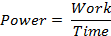State the relationship between work and power, and perform simple calculations based on this relationship.
Power is the rate at which work is done.

